Installing Custom Metrics in Windows Server

Step 1: Go to IAM console and create a new EC2 role with cloud watch full access and cloud watch agent Server Policy and attach it to the instance for which your want to monitor custom metrics.

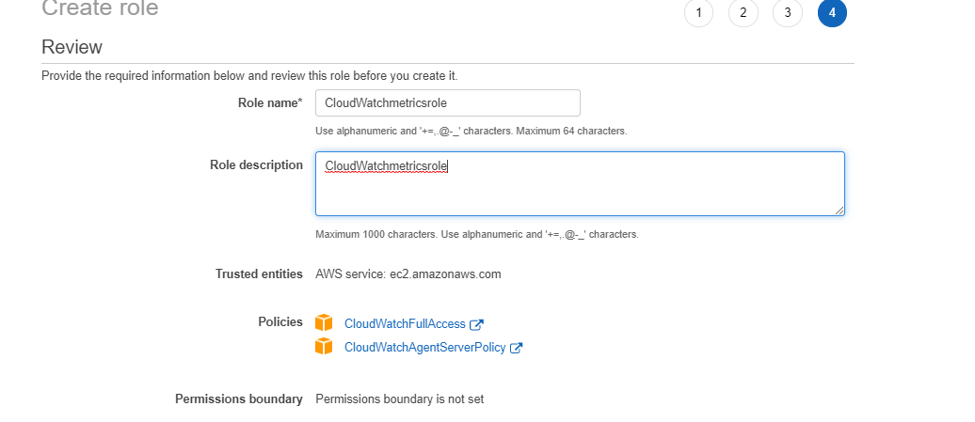

Step 2: Now connect to the instance and download the agent msi file from the below link.
https://s3.amazonaws.com/amazoncloudwatch-agent/windows/amd64/latest/amazon-cloudwatch-agent.msi
Step 3: Now open command prompt from the location where you saved the file and run the below command.
msiexec /i amazon-cloudwatch-agent.msi
Now we have installed the cloud watch agent now we should create the metric configuration file.
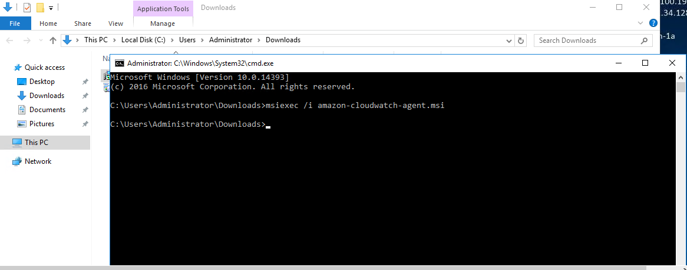
Step 4: Now to create a cloud watch agent configuration file use the below command in power shell.
cd "C:\Program Files\Amazon\AmazonCloudWatchAgent"
./amazon-cloudwatch-agent-config-wizard.exe
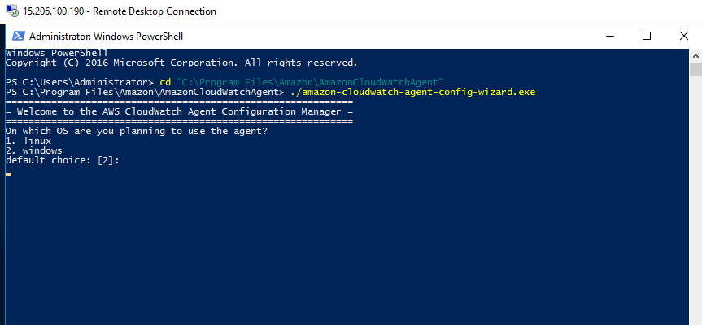
Step 5: Now follow the below number for the questions that you see on the screen or we can select as per our requirements.
2 - enter
1 - enter
2 - enter
2 – enter
1 – enter
2 – enter
1 – enter
4 – enter
3 – enter
Now check the json configuration file and enter 1 – enter
2 – enter
2 – enter
2 – enter and enter again to exit the file
Step 5: Now we need to start the agent by using the below command in power shell.
& "C:\Program Files\Amazon\AmazonCloudWatchAgent\amazon-cloudwatch-agent-ctl.ps1" -a fetch-config -m ec2 -s -c file:(configuration-file-path)

Configuration file path: go to c>program files>amazon>amazon cloud watch agent>config.json
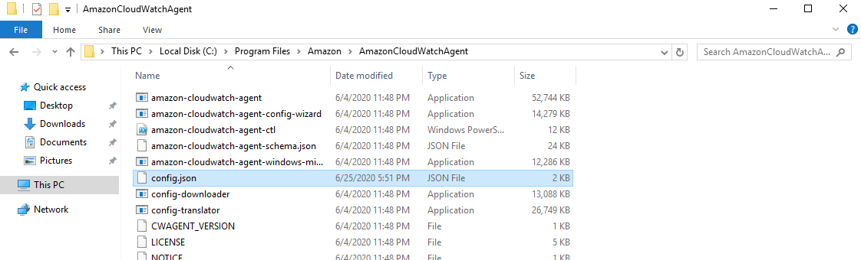

Now replace this file path in the above command.
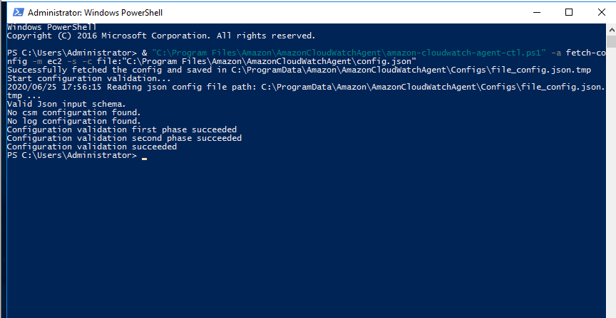

Now the agent is running we can check in the services window.
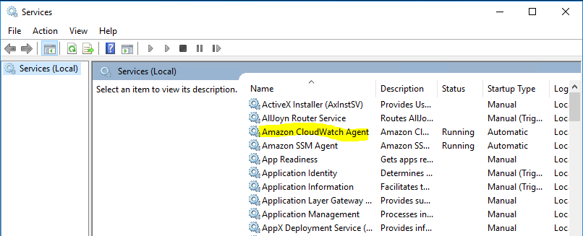

Step 6: Now go to cloud watch console and go to metrics.
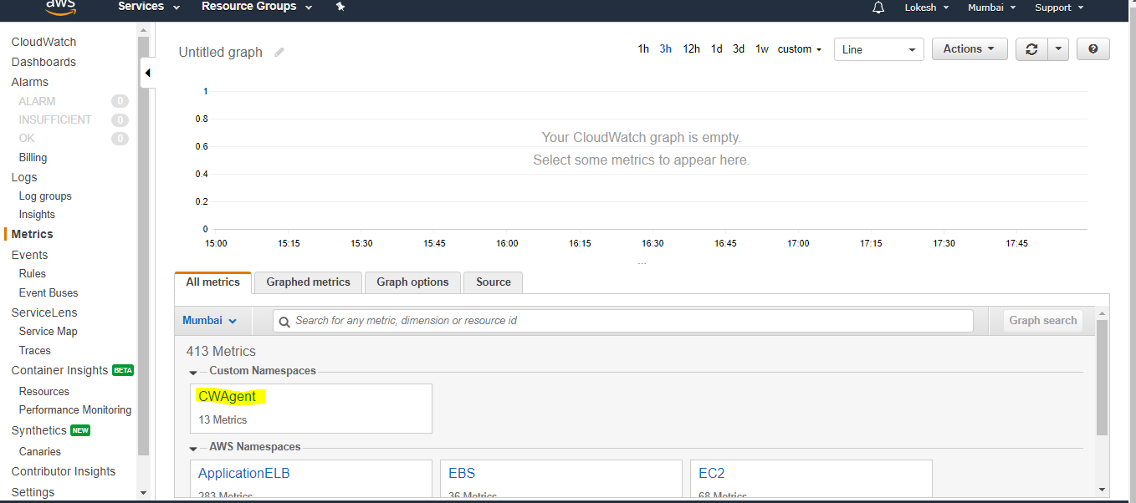
Here in all metrics, you will find CWAgent metrics, inside that we can see the metrics for memory and network and other metrics that we mentioned in configuration file.

